SIMATS ENGINEERING
ASSESSMENT TOOL 1

COURSE NAME: MLA03
COURSE CODE: Reinforcement learning

COURSE OUTCOME COVERED
CO1: Analyze reinforcement learning frameworks and Markov Decision Process concepts to model decision-making problems. (BL2, BL3)
Assessment Tool Weightage: 50%

Dr.T.P.Anithaashri
QUESTIONS: 10 Total Marks: 50
Annexure A
RL Basic Experiments demo with Keras and TensorFlow using Anaconda navigator
Duration: 2hrs

Code of Conduct:
I K.Vijay Bhaskar Reddy(192425155) certify that this submission is my original work and that I have adhered to the guidelines specified for this assessment.
I understand that any violation of academic integrity rules will result in disciplinary action.
Signature of the student:


Experiment 1

Title: Installation of Reinforcement Learning Development Environment
Aim: To install and configure Python, TensorFlow, Keras, Gymnasium, NumPy and Matplotlib and verify the RL environment.
Algorithm:
• Import the required libraries.
• Initialize the environment/model.
• Execute the required RL procedure.
• Display the output.
• Verify the result.
Program & Output:
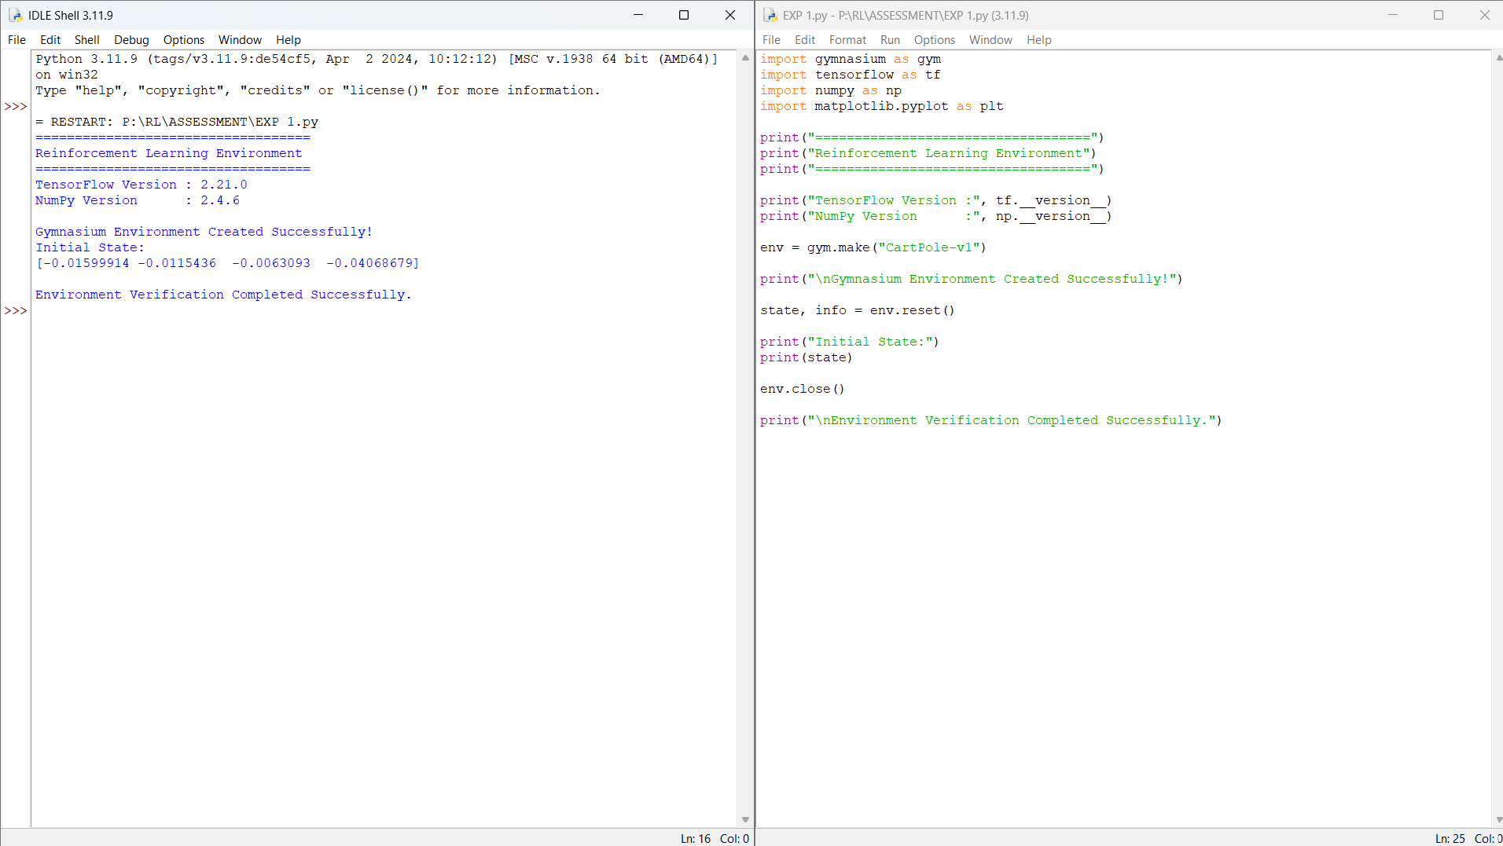

Result: The experiment was executed successfully and the expected output was obtained.

Experiment 2
Title: Familiarization with OpenAI Gym/Gymnasium Environments
Aim: To create and interact with the FrozenLake environment and understand states, actions, rewards and episodes.
Algorithm:
• Import the required libraries.
• Initialize the environment/model.
• Execute the required RL procedure.
• Display the output.
• Verify the result.
Program & Output:
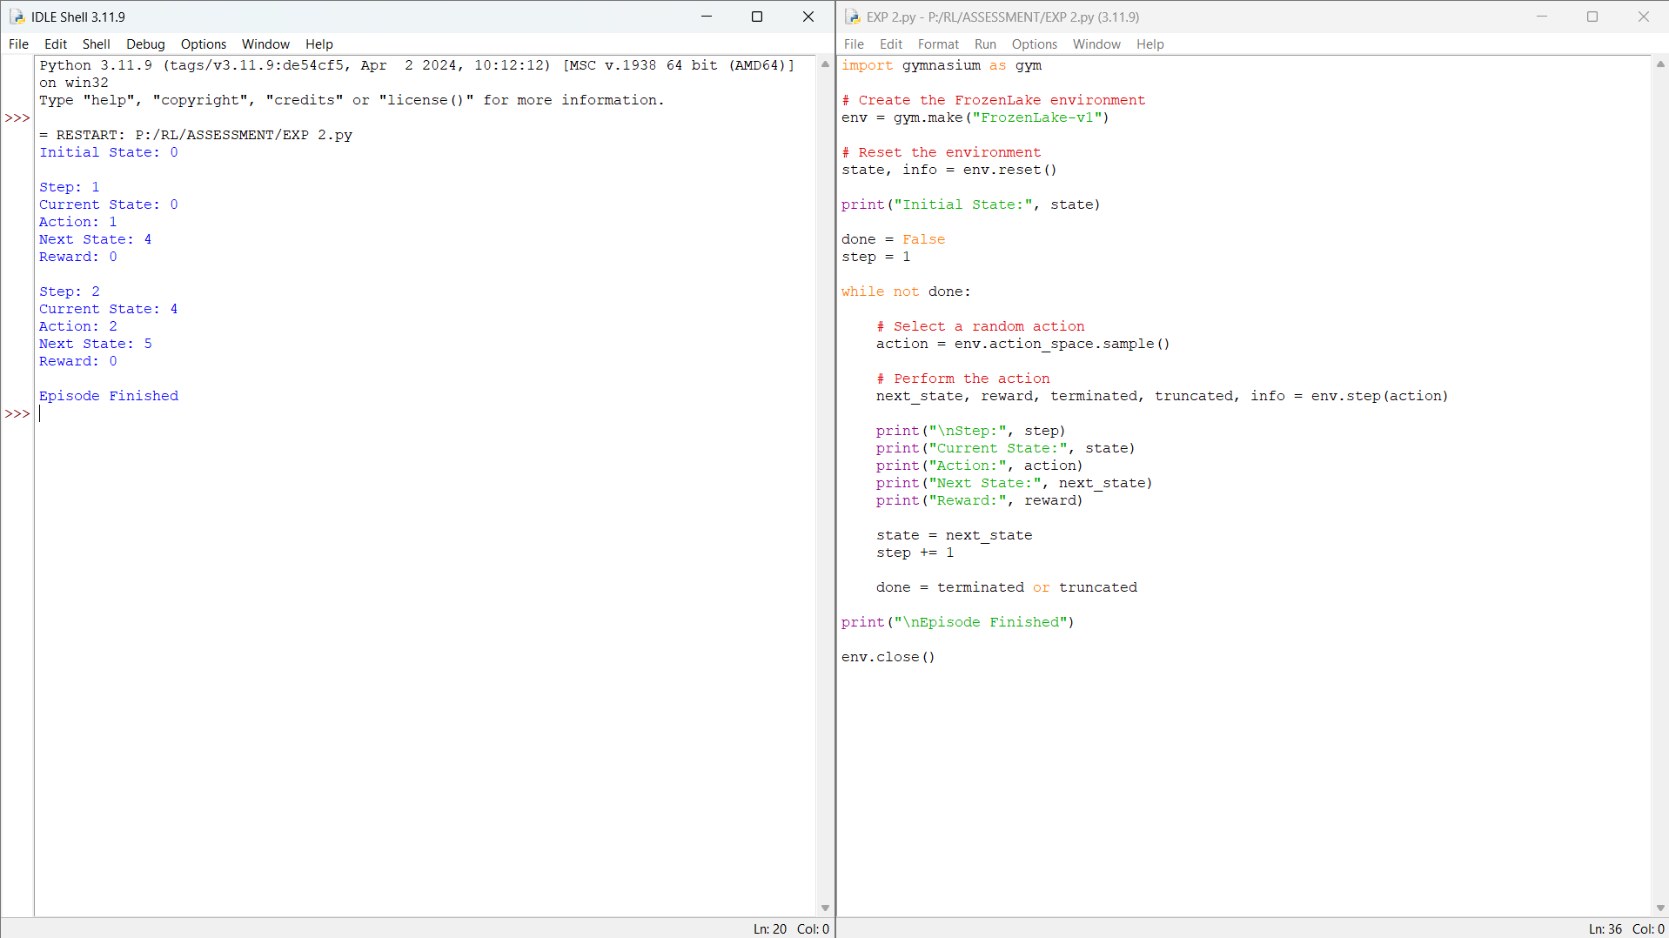

Result: The experiment was executed successfully and the expected output was obtained.

Experiment 3
Title: Implementation of Reinforcement Learning Framework
Aim: To implement the basic RL framework using an agent interacting with the environment.
Algorithm:
• Import the required libraries.
• Initialize the environment/model.
• Execute the required RL procedure.
• Display the output.
• Verify the result.
Program & Output:
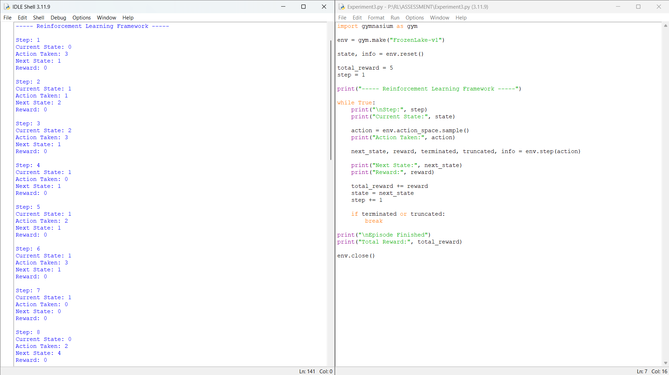

Result: The experiment was executed successfully and the expected output was obtained.

Experiment 4
Title: Simulation of Markov Decision Process (MDP)
Aim: To simulate state transitions, rewards and policies using a simple MDP.
Algorithm:
• Import the required libraries.
• Initialize the environment/model.
• Execute the required RL procedure.
• Display the output.
• Verify the result.
Program & Output:
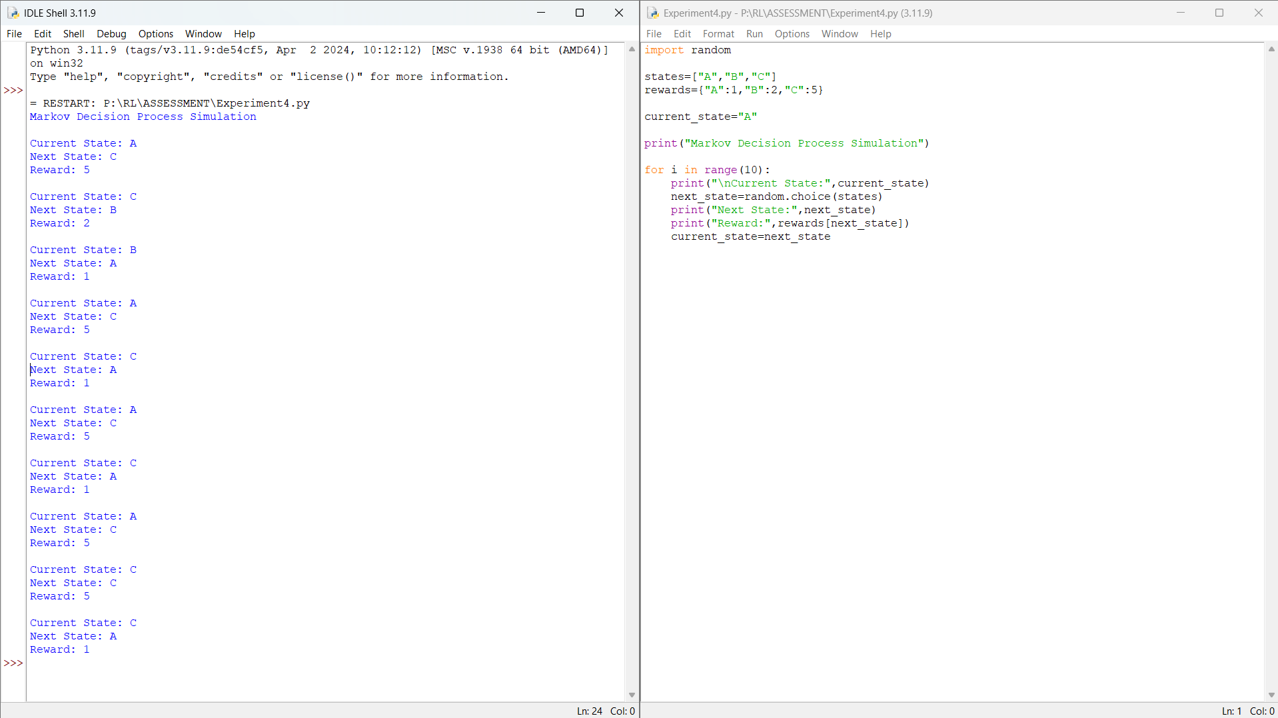

Result: The experiment was executed successfully and the expected output was obtained.

Experiment 5
Title: Bellman Equation Demonstration
Aim: To implement Bellman Expectation and Bellman Optimality equations.
Algorithm:
• Import the required libraries.
• Initialize the environment/model.
• Execute the required RL procedure.
• Display the output.
• Verify the result.
Program & Output:
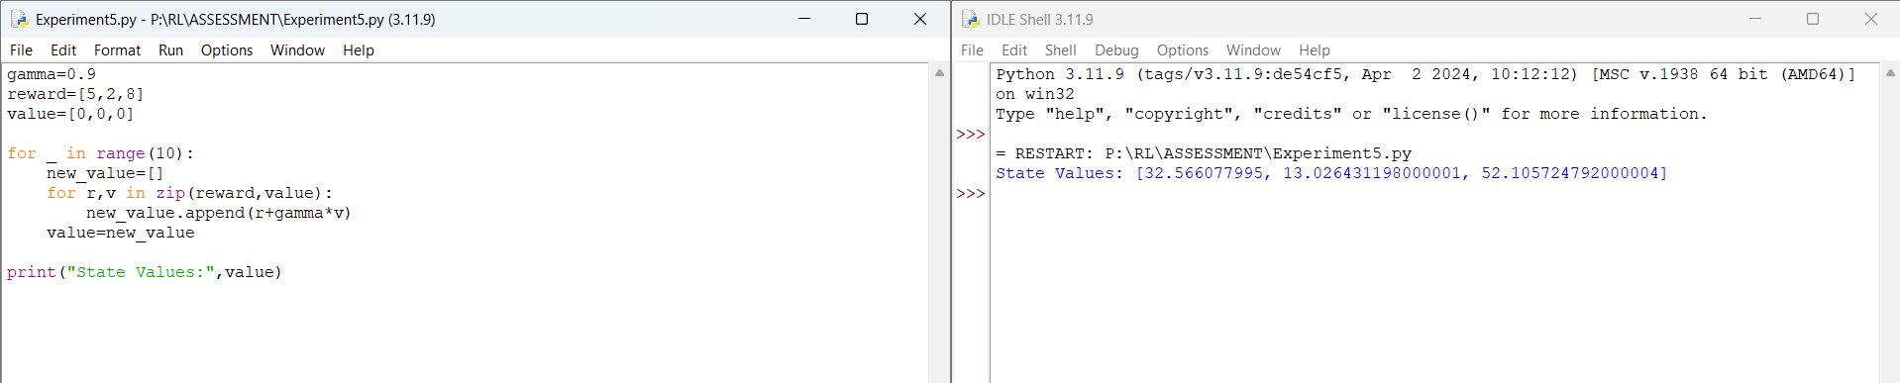

Result: The experiment was executed successfully and the expected output was obtained.

Experiment 6
Title: Exploration vs Exploitation
Aim: To compare Greedy, ε-Greedy and Random strategies.
Algorithm:
• Import the required libraries.
• Initialize the environment/model.
• Execute the required RL procedure.
• Display the output.
• Verify the result.
Program & Output:
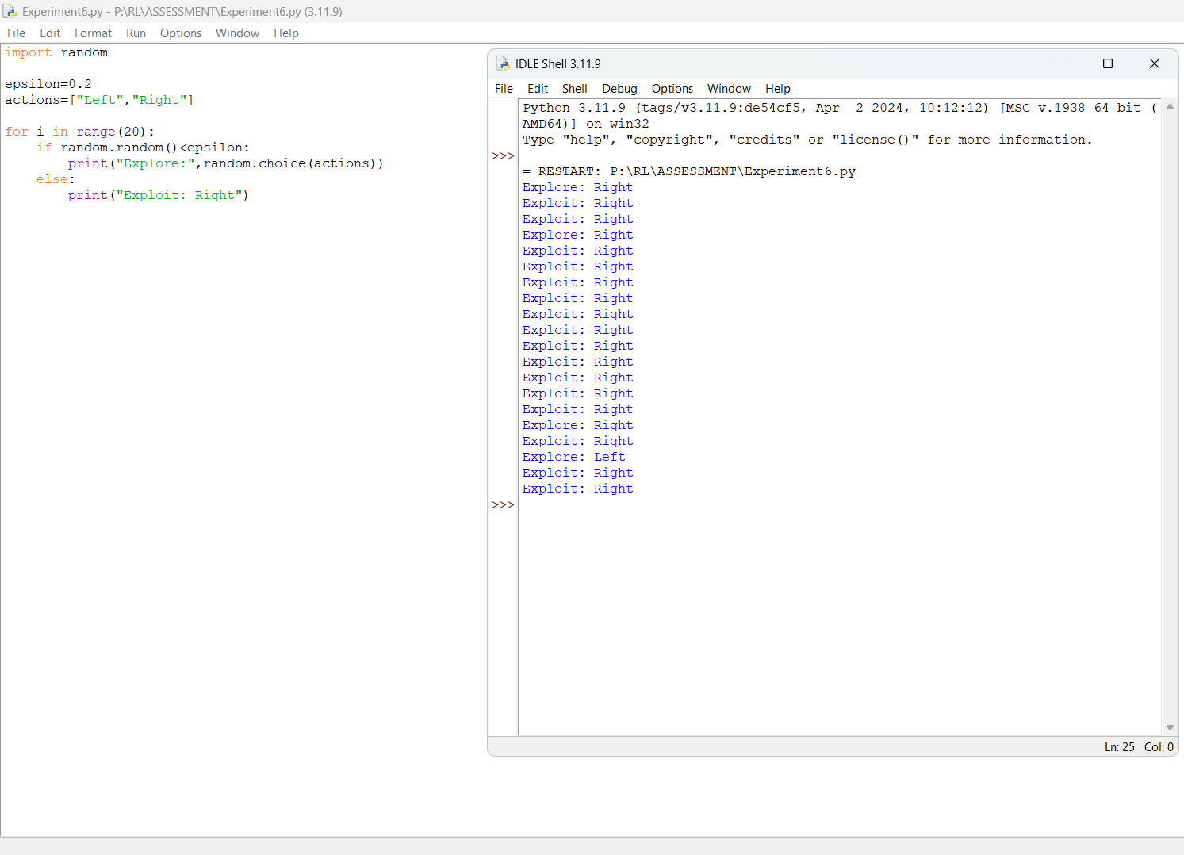

Result: The experiment was executed successfully and the expected output was obtained.

Experiment 7
Title: Multi-Armed Bandit Problem
Aim: To implement the Multi-Armed Bandit problem using ε-Greedy.
Algorithm:
• Import the required libraries.
• Initialize the environment/model.
• Execute the required RL procedure.
• Display the output.
• Verify the result.
Program & Output:
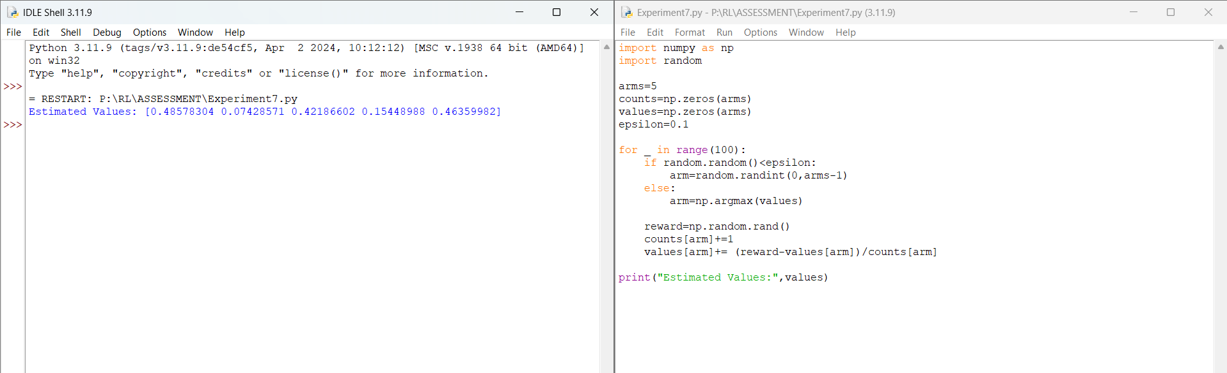

Result: The experiment was executed successfully and the expected output was obtained.

Experiment 8
Title: Reward Visualization
Aim: To visualize cumulative rewards using Matplotlib.
Algorithm:
• Import the required libraries.
• Initialize the environment/model.
• Execute the required RL procedure.
• Display the output.
• Verify the result.
Program & Output:
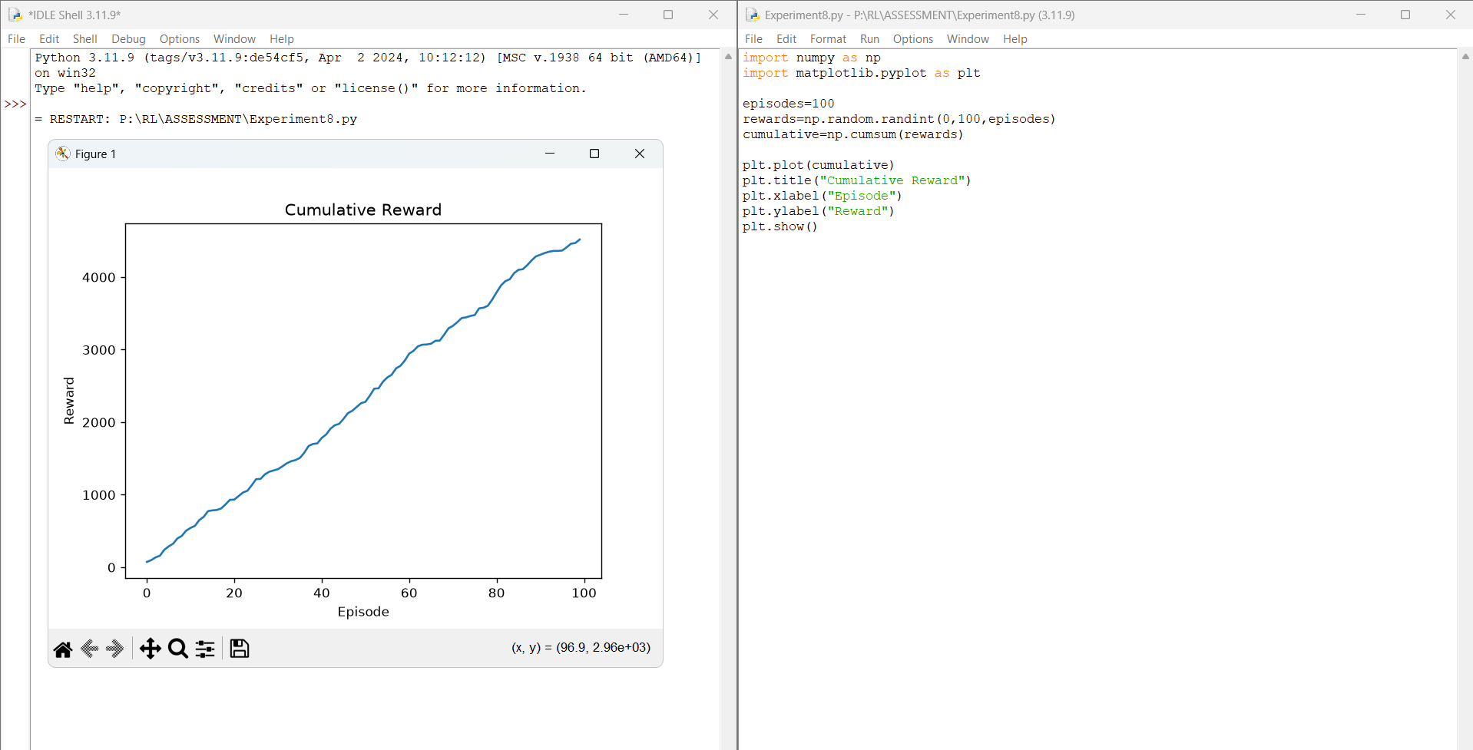
Result: The experiment was executed successfully and the expected output was obtained.

Experiment 9
Title: TensorFlow and Keras Neural Network
Aim: To build a simple feed-forward neural network for RL.
Algorithm:
• Import the required libraries.
• Initialize the environment/model.
• Execute the required RL procedure.
• Display the output.
• Verify the result.
Program & Output:
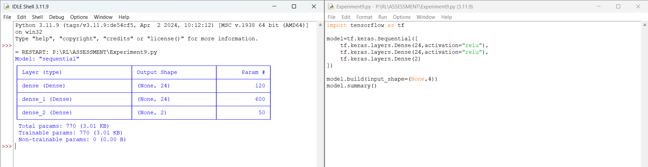

Result: The experiment was executed successfully and the expected output was obtained.

Experiment 10
Title: Mini Reinforcement Learning Project Using CartPole
Aim: To develop a basic RL agent for the CartPole environment.
Algorithm:
• Import the required libraries.
• Initialize the environment/model.
• Execute the required RL procedure.
• Display the output.
• Verify the result.
Program & Output:
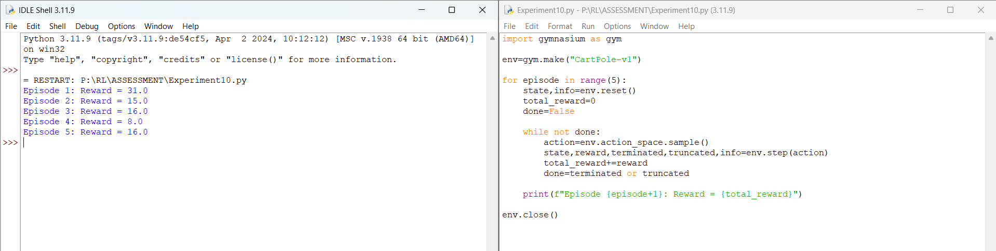
Result: The experiment was executed successfully and the expected output was obtained.

